Hi professor, I’ve hi-lited parts 1 and 2 to make it easier for you to identify those pieces. I hope this helps and have a great day!

Part 1

Lessons 01 & 02

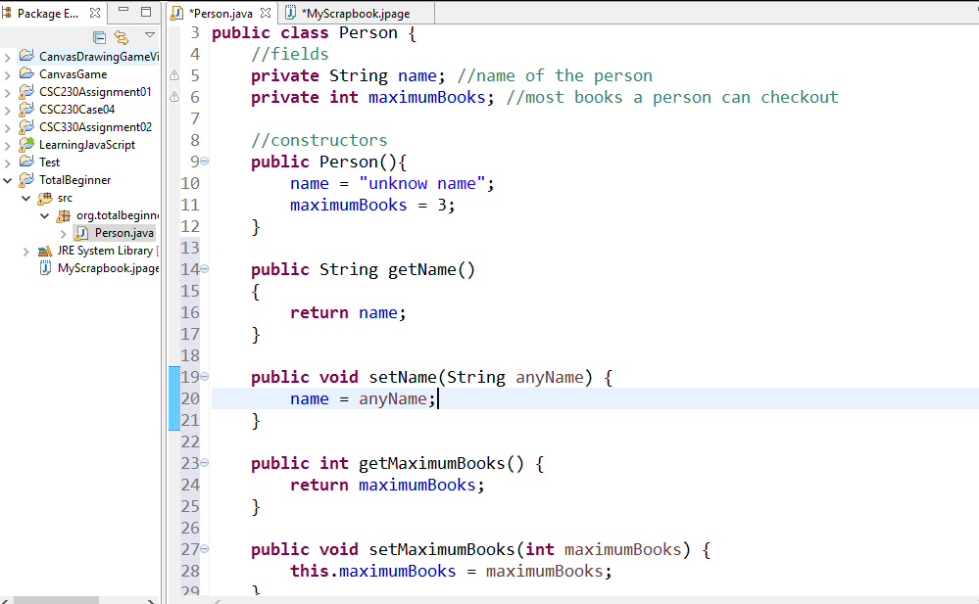

Lesson 03

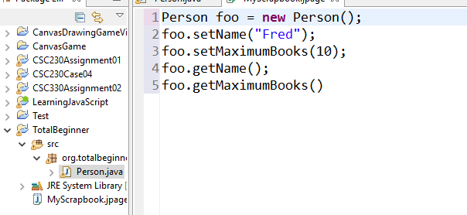

Lesson 04

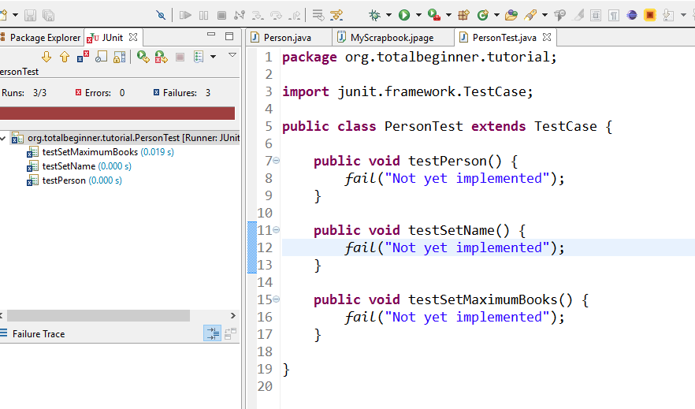

Lesson 05

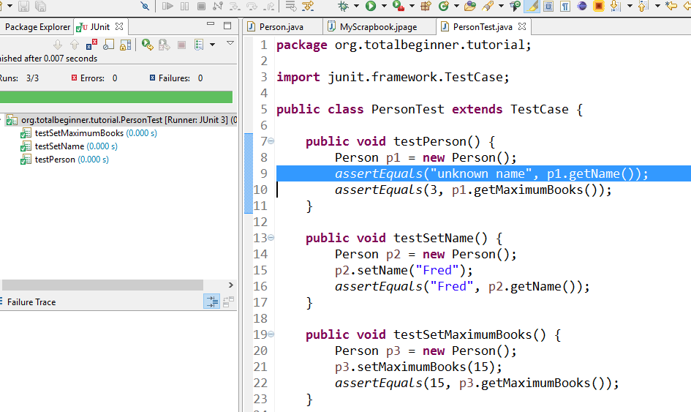

Lesson 06

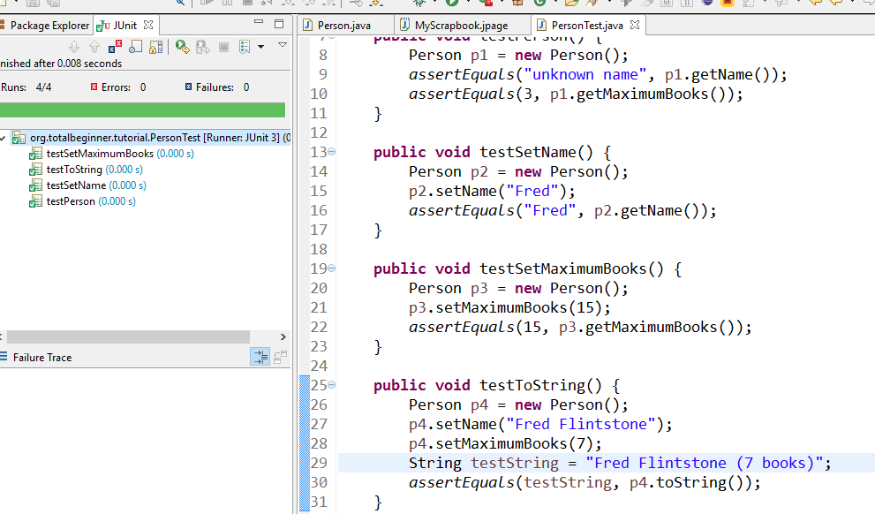

Lesson 07

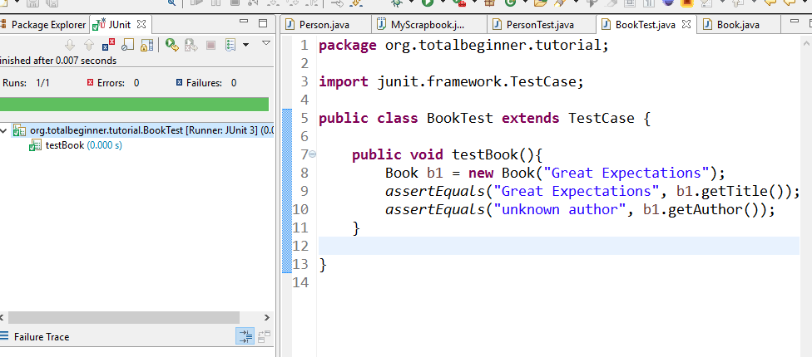

Lesson 08

<https://www.youtube.com/watch?v=po2wj0J21J4&list=PLv6UtFrA7VEu4PtzJaGHHSeZBi6mdJtwv>

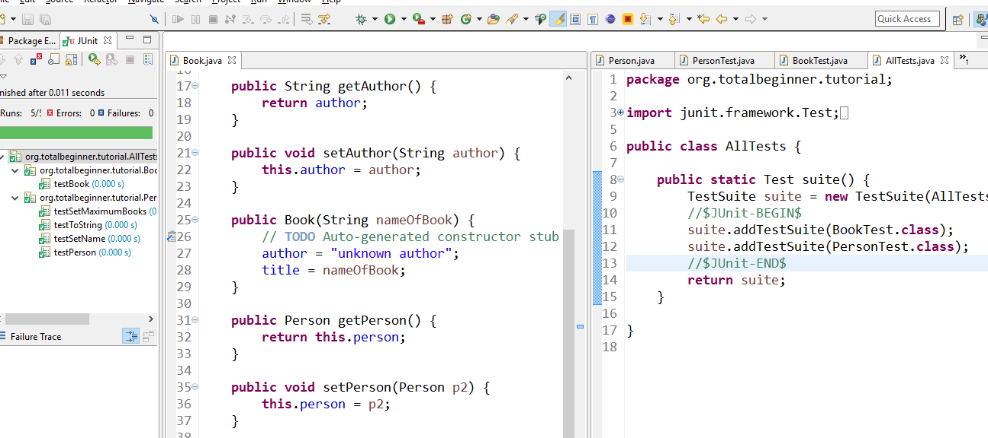

Lesson 09

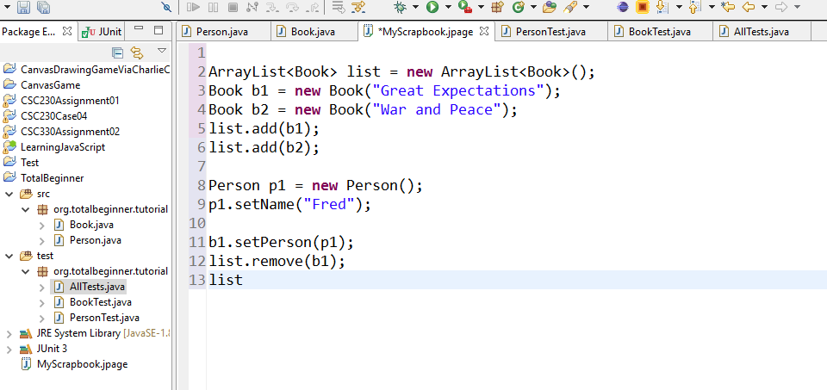

Lesson 10

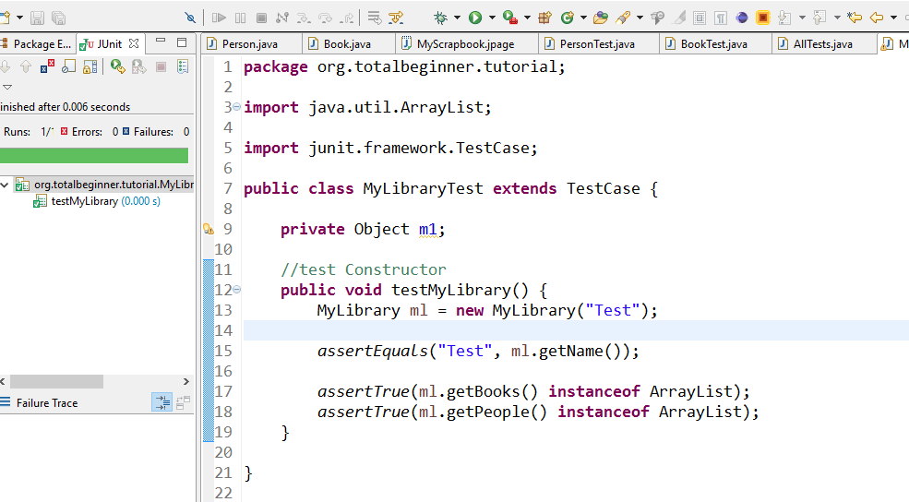

Lesson 11

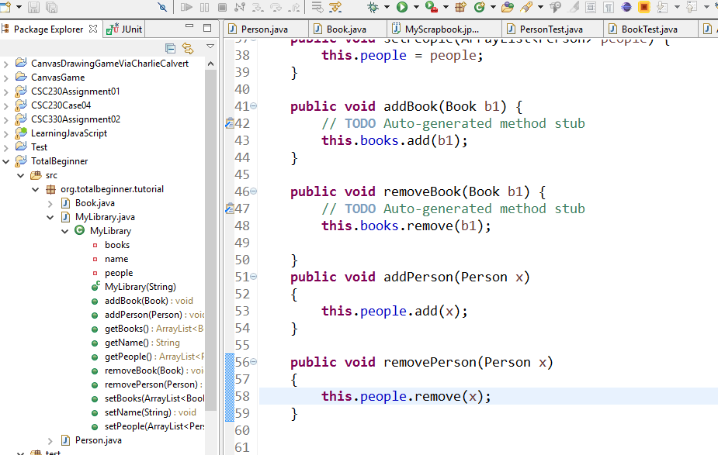

Lesson 12

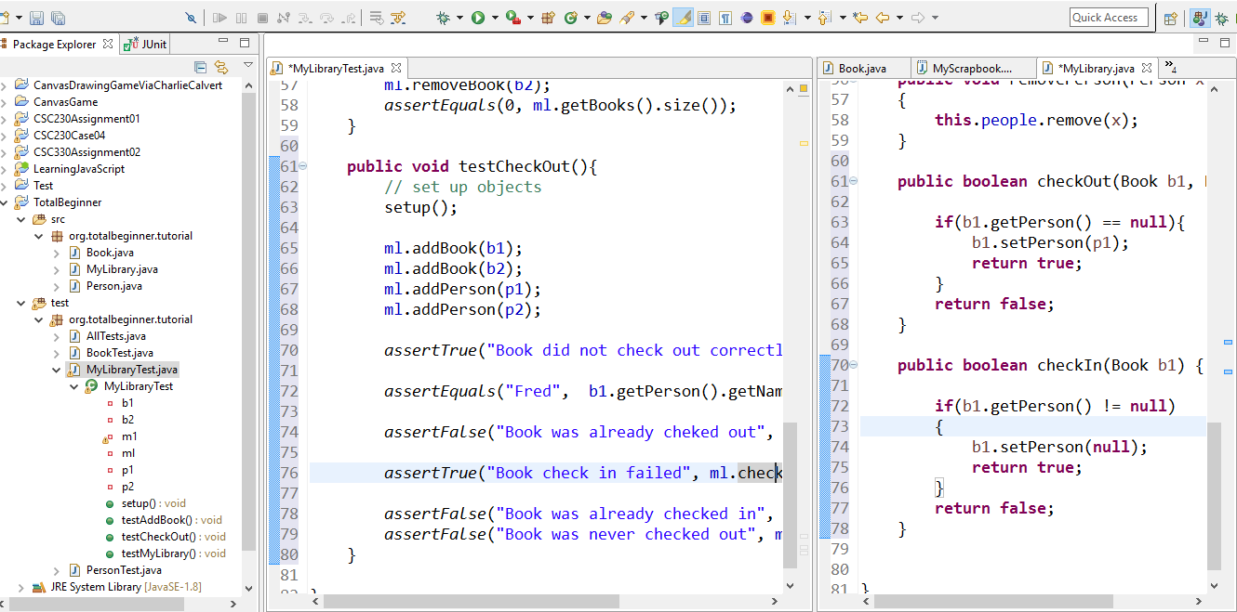

Lesson 13

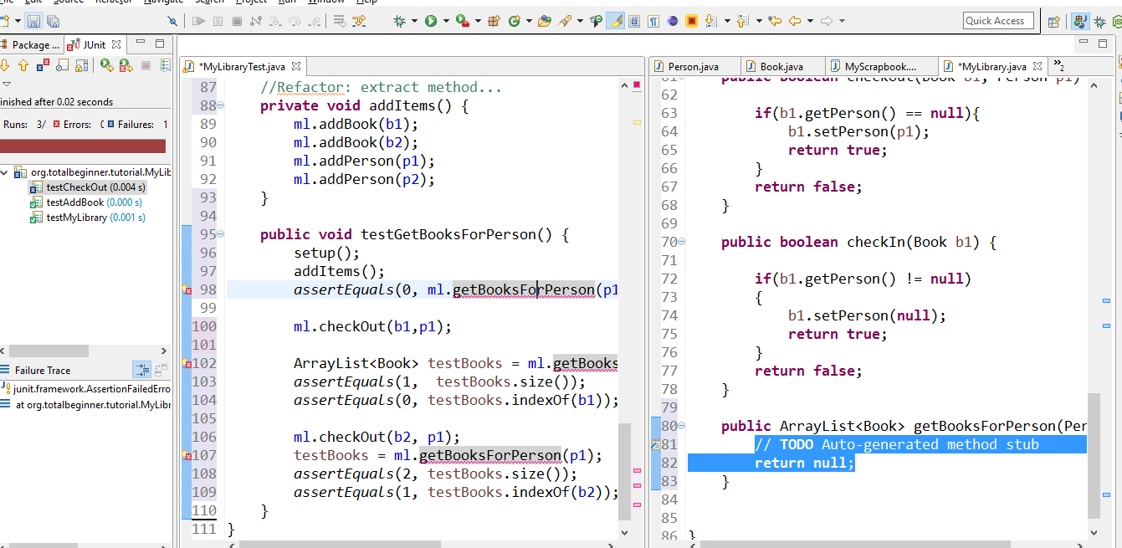

Lesson 14

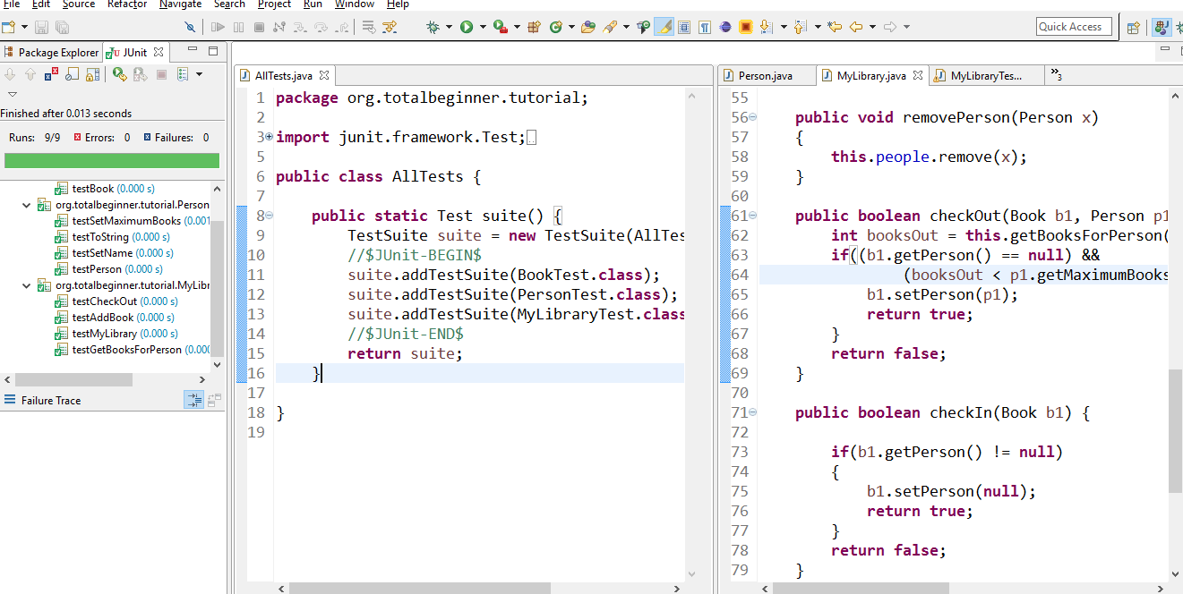

Lesson 15

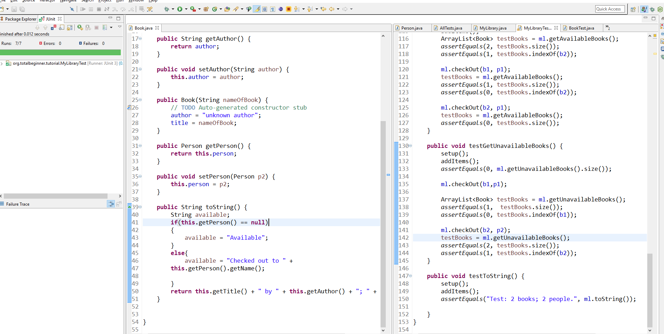

Lesson 16

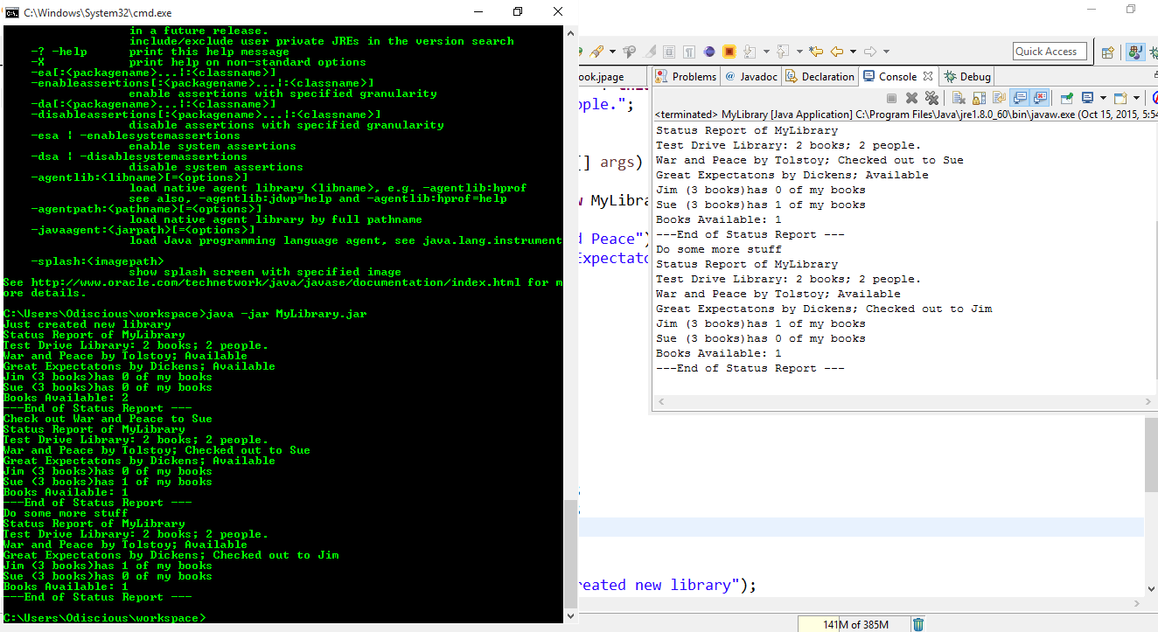

Part 2

